**Python程式設計**

**範圍： list、tuple的應用**

**銘傳大學電腦與通訊工程系**

|  |  |
| --- | --- |
| 班 級 | 電通四乙 |
| 姓 名 | 郭凡智 |
| 學 號 | 05050164 |
| 成 績 | 應繳作業共 10 題，每題10分，滿分為100分  共完成 題，應得 分 |
| 授課教師 | 陳慶逸 |

※直接將你的程式碼貼在指定的欄位裡，並且執行題目要求的輸入參數(每一題都有5個不同的輸入參數要執行)，再將執行結果擷圖貼在指定的位置。

※請確實填寫自己寫完成題數，並且計算得分。填寫不實者(如上傳與作業明顯無關的答案，或是計算題數有誤者)，本次作業先扣50分。

EX 1: 試以串列解析式語法來改寫下面的兩個以for-loop所寫的程式：

1. 新串列的內容為原串列的所有元素都乘上2的結果：

For-loop迭代作法：

|  |
| --- |
| **num = [1, 2, 3, 4, 5]**  **doubledOddNum = []**  **for n in num:**  **doubledOddNum.append(n * 2)**  **print(doubledOddNum) #[2, 4, 6, 8, 10]** |

串列解析式語法：

|  |
| --- |
| **list1 = [x for x in range(2,11,2)]**  **print(list1)** |

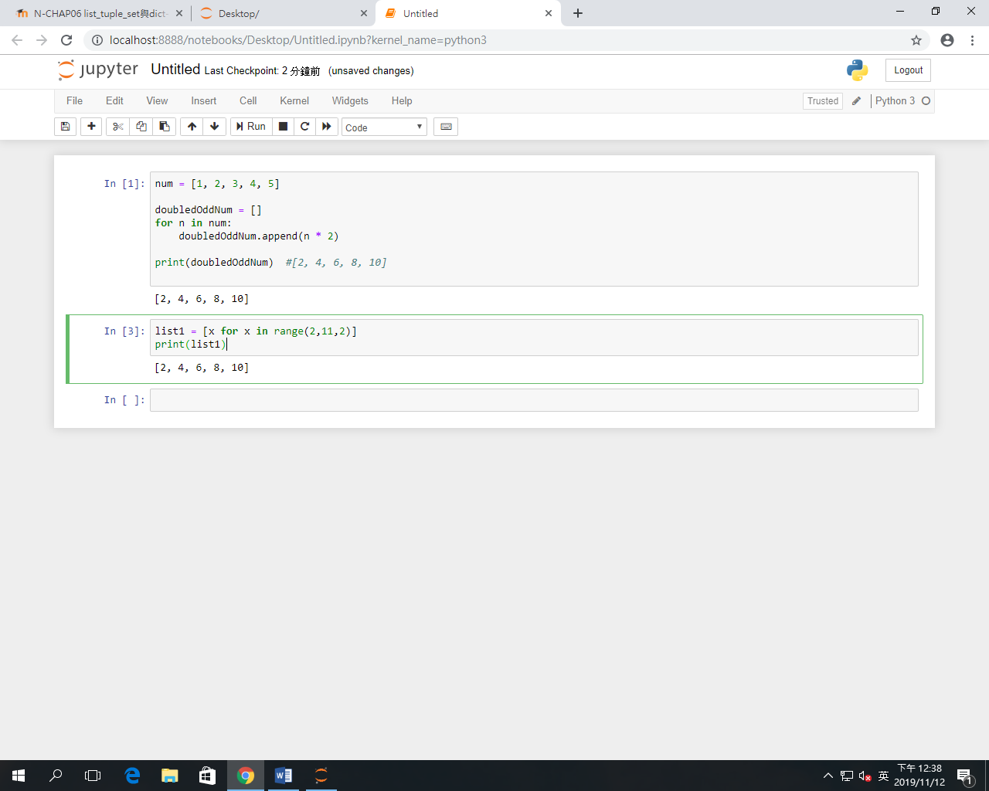

(2) 新串列的內容為原串列的所有奇數值元素都乘上2的結果：

For-loop迭代作法：

|  |
| --- |
| **num = [1, 2, 3, 4, 5]**  **doubledOddNum = []**  **for n in num:**  **if n % 2 == 1:**  **doubledOddNum.append(n * 2)**  **print(doubledOddNum) #[2, 6, 10]** |

串列解析式語法：

|  |
| --- |
| **list2 = [x*2 for x in range(1,6) if x%2==1]**  **print(list2)** |

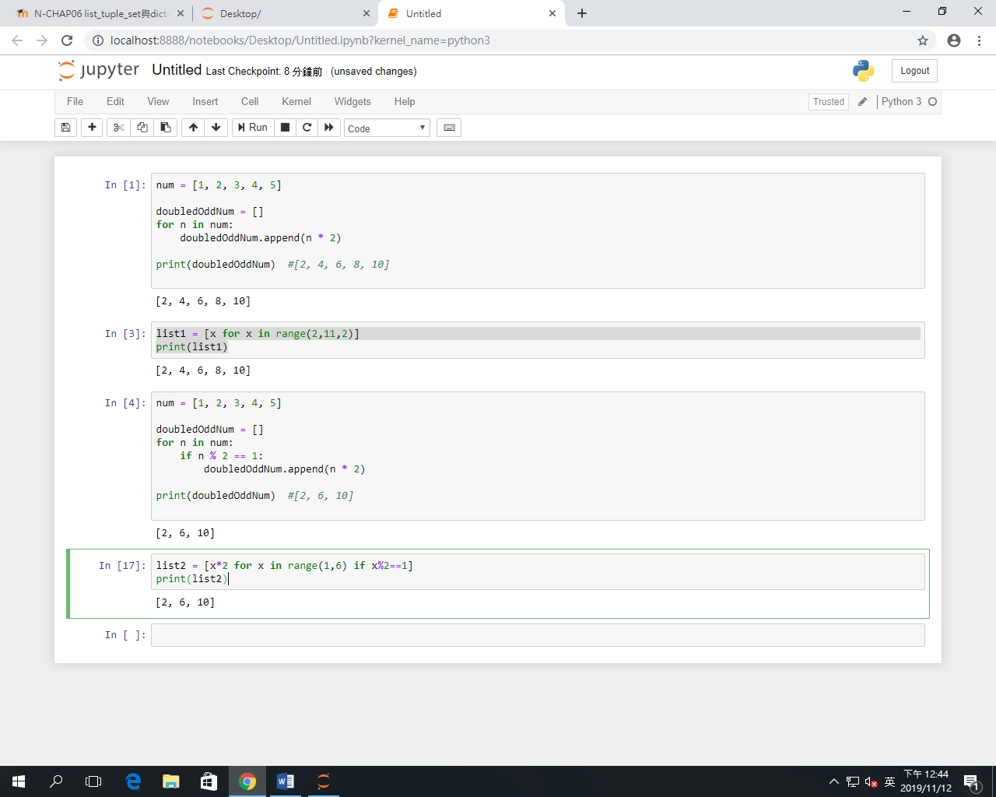

EX 2: 試寫一個Python程式來產生一個3x4x6的三維陣列。

輸出如下:

[[['0', '0', '0', '0', '0', '0'], ['0', '0', '0', '0', '0', '0'], ['0', '0', '0', '0', '0', '0'], ['0', '0', '0', '0', '0', '0']], [['0', '0', '0', '0', '0', '0'], ['0', '0', '0', '0', '0', '0'], ['0', '0', '0', '0', '0', '0'], ['0', '0', '0', '0', '0', '0']], [['0', '0', '0', '0', '0', '0'], ['0', '0', '0', '0', '0', '0'], ['0', '0', '0', '0', '0', '0'], ['0', '0', '0', '0', '0', '0']]]

|  |
| --- |
| **list3 = [[[0 for x in range(0,6)]for y in range(0,4)]for z in range(0,3)]**  **print(list3)** |

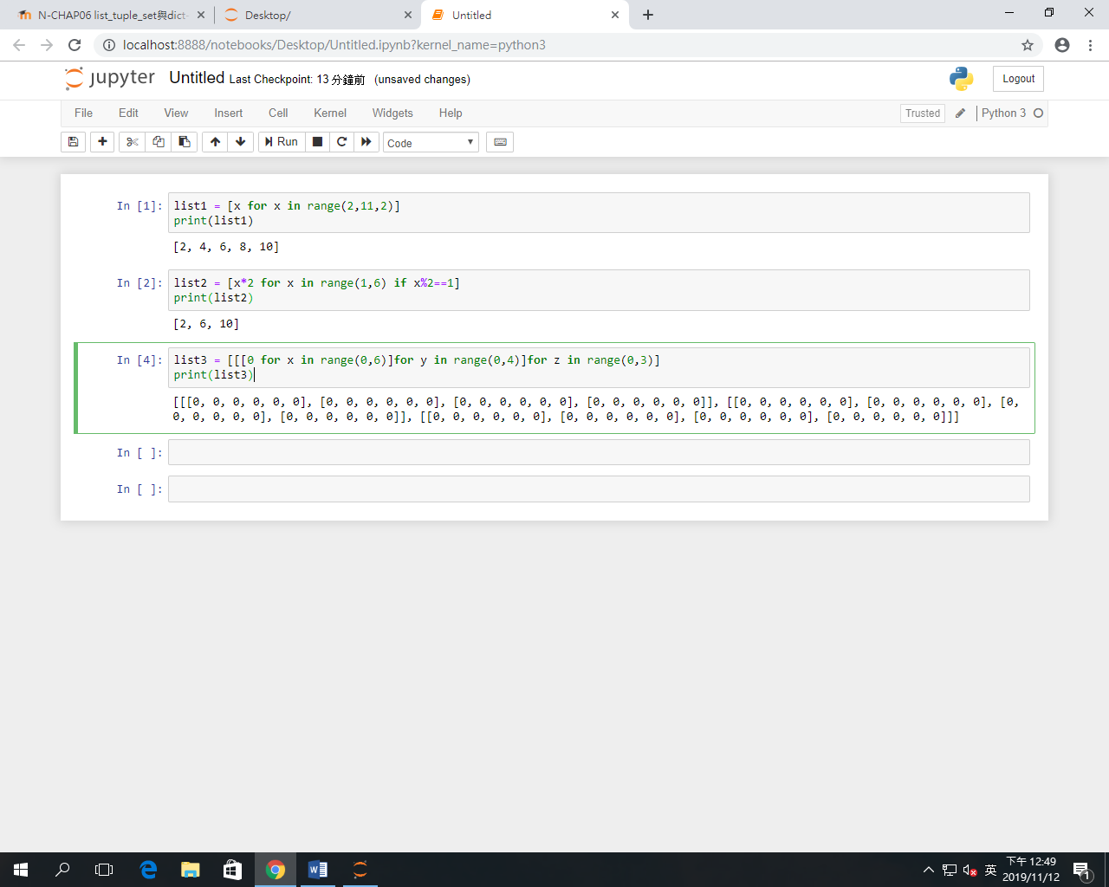

EX 3: 若有一串列a = [[1, 2, 3, 4], [5, 6], [7, 8, 9]]，試計算此串列裡所有元素的總和。

|  |
| --- |
| **a = [[1, 2, 3, 4], [5, 6], [7, 8, 9]]**  **a = [[1, 2, 3, 4], [5, 6], [7, 8, 9]]**  **ans=0**  **for j in range (0,3):**  **for i in range(len(a[j])):**  **ans=a[j][i]+ans**  **print(ans)** |

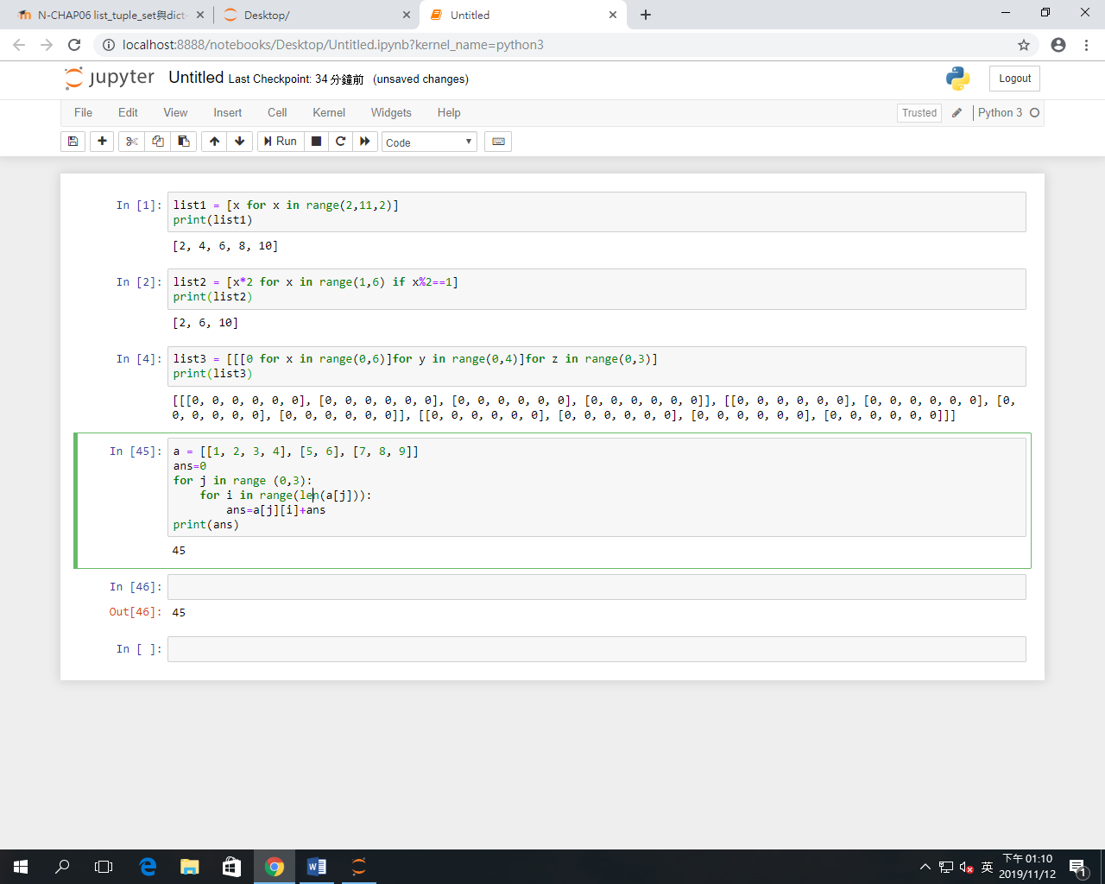

EX 4: 若串列A = [ [1, 2, 3, 0], [4, 5, 6, 0], [7, 8, 9, 0] ]，串列B = [ [2, 4, 6, 0], [1, 3, 5, 0], [0, -1, -2, 0] ]；試產生一個相同尺寸的串列C，且其內容為A + B (矩陣相加)的結果。

|  |
| --- |
| **A = [ [1, 2, 3, 0], [4, 5, 6, 0], [7, 8, 9, 0] ]**  **B = [ [2, 4, 6, 0], [1, 3, 5, 0], [0, -1, -2, 0] ]**  **C = [[A[i][j]+B[i][j] for j in range(0,4)]for i in range(0,3)]**  **print(C)** |

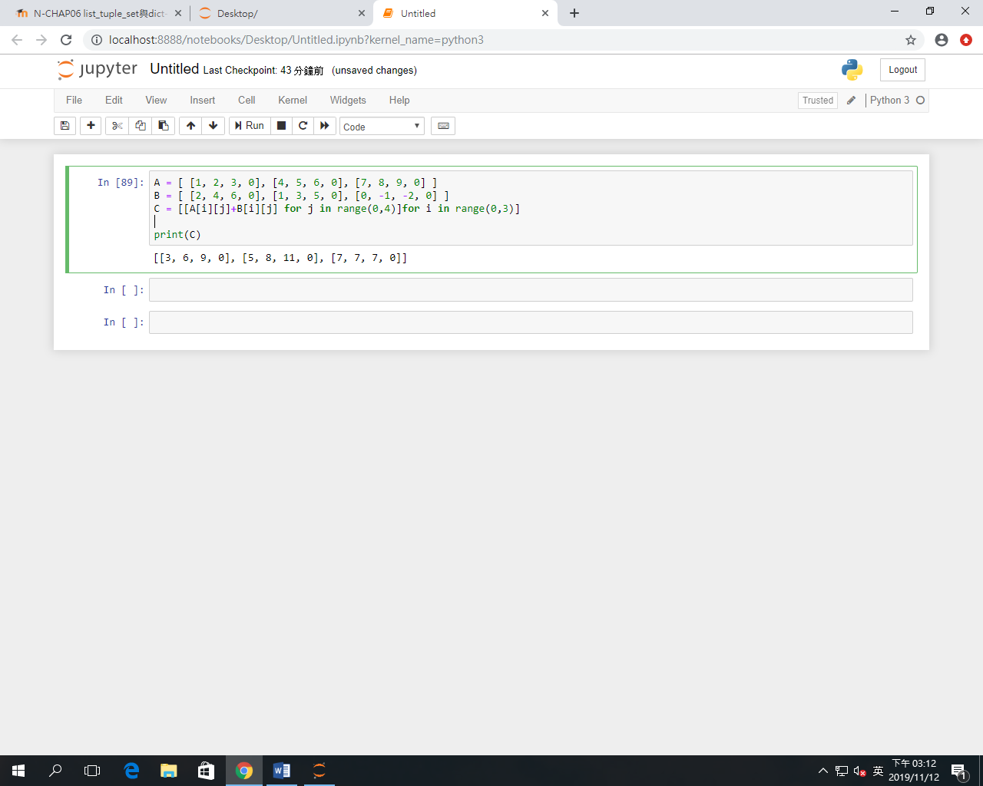

EX 5: 試寫一個Python程式，它能移除輸入之串列中所有的偶數數值。

例如:

輸入: [7, 8, 120, 25, 44, 20, 27]

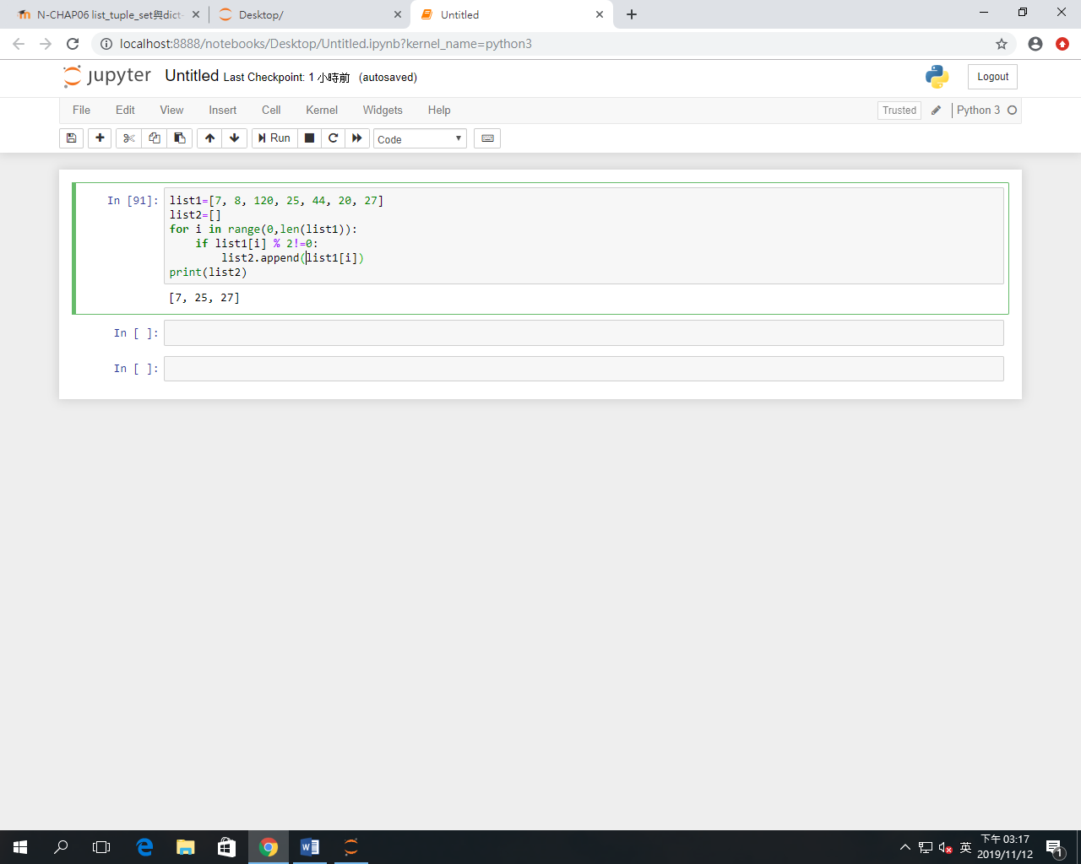輸出: [7, 25, 27]

|  |
| --- |
| **list1=[7, 8, 120, 25, 44, 20, 27]**  **list2=[]**  **for i in range(0,len(list1)):**  **if list1[i] % 2!=0:**  **list2.append(list1[i])**  **print(list2)** |

EX 6: 試撰寫一個Python函式tuplexEdit(tuplex)，並利用資料型別轉換的作法，刪除所傳遞進來之tuple從前面算過來第4個項目，以及從末端算過來第4個項目的內容(假設tuple的長度均超過10)，並回傳更改後的tuple內容。

例如:

|  |  |
| --- | --- |
| **輸入** | **執行結果** |
| **print(tuplexEdit(("E", "m", "b", "e", "d", "e", "d", "S", "y", "s", "t", "e", "m")))** | **('E', 'm', 'b', 'd', 'e', 'd', 'S', 'y', 't', 'e', 'm')** |
| **print(tuplexEdit(("1", "2", "3", "4", "5", "6", "7", "8", "9", "10", "11", "12", "13")))** | **('1', '2', '3', '5', '6', '7', '8', '9', '11', '12', '13')** |

我的作答：

**請在下面欄位貼上程式碼：**

|  |
| --- |
| **def tuplexEdit(tuplex):**  **list1 = list(tuplex)**  **list1.pop(3)**  **list1.pop(-4)**  **return list1**  **print(tuplexEdit(("E", "m", "b", "e", "d", "e", "d", "S", "y", "s", "t", "e", "m")))**  **print(tuplexEdit(("1", "2", "3", "4", "5", "6", "7", "8", "9", "10", "11", "12", "13")))**  **print(tuplexEdit((7, 5, 4, 41, 2, 5, 6, 2, "y", "4", "3", 1)))**  **print(tuplexEdit(("P", "y", "t", "h", "o", "n", "w", "o", "r", "k")))**  **print(tuplexEdit(("m", "a", "t", "l", "a", "b", "d", "i", "y", "s")))** |

**請依下面要求輸入參數，並將執行結果擷圖:**

|  |  |
| --- | --- |
| **print(tuplexEdit(("E", "m", "b", "e", "d", "e", "d", "S", "y", "s", "t", "e", "m")))** | ['E', 'm', 'b', 'd', 'e', 'd', 'S', 'y', 't', 'e', 'm'] |
| **print(tuplexEdit(("1", "2", "3", "4", "5", "6", "7", "8", "9", "10", "11", "12", "13")))** | ['1', '2', '3', '5', '6', '7', '8', '9', '11', '12', '13'] |
| **print(tuplexEdit((7, 5, 4, 41, 2, 5, 6, 2, "y", "4", "3", 1)))** | [7, 5, 4, 2, 5, 6, 2, '4', '3', 1] |
| **print(tuplexEdit(("P", "y", "t", "h", "o", "n", "w", "o", "r", "k")))** | ['P', 'y', 't', 'o', 'n', 'o', 'r', 'k'] |
| **print(tuplexEdit(("m", "a", "t", "l", "a", "b", "d", "i", "y", "s")))** | ['m', 'a', 't', 'a', 'b', 'i', 'y', 's'] |

**執行結果擷圖：**

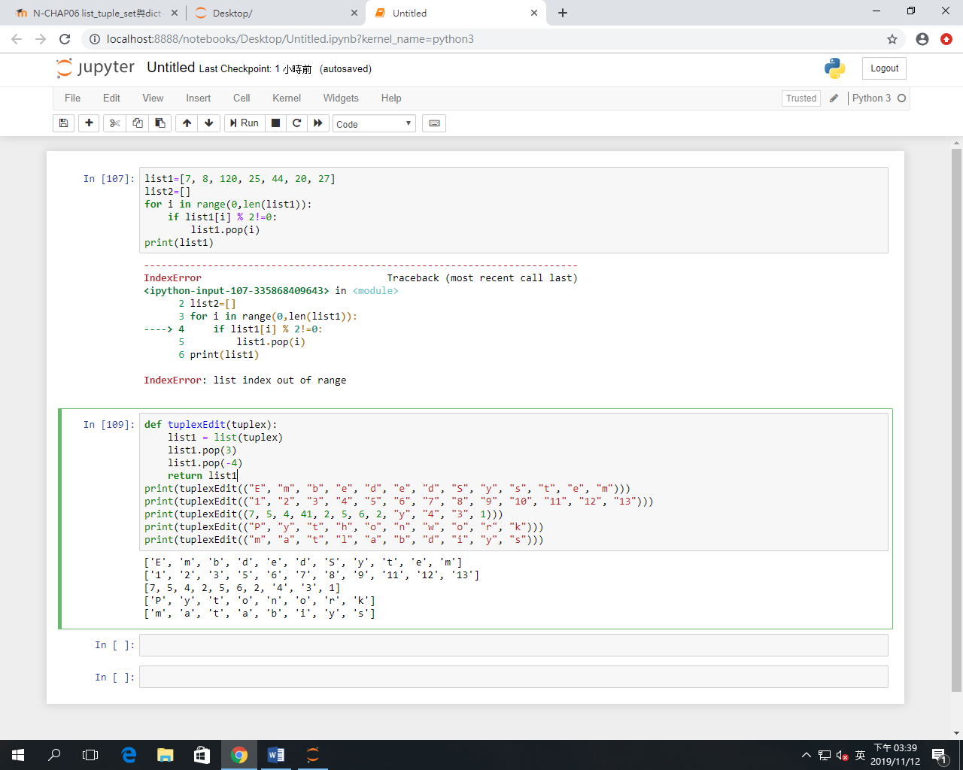

EX 7: 試撰寫一個Python函式tuplexcount(tuplex)，它能計算傳遞進來的tuple之每一個項目出現的次數 ，並儲存成一個list回傳內容。

例如:

|  |  |
| --- | --- |
| **輸入** | **執行結果** |
| **print(tuplexcount(("E", "m", "b", "b", "E")))** | [2, 1, 2, 2, 2] |
| **print(tuplexcount(("1", "3", "3", "4", "4", "6", "7", "3")))** | [1, 3, 3, 2, 2, 1, 1, 3] |

我的作答：

**請在下面欄位貼上程式碼：**

|  |
| --- |
| **def tuplexcount(tuplex):**  **list1=[]**  **for i in range(0,len(tuplex)):**  **list1.append(tuplex.count(tuplex[i]))**  **return list1**  **print(tuplexcount(("E", "m", "b", "b", "E")))**  **print(tuplexcount(("1", "3", "3", "4", "4", "6", "7", "3")))**  **print(tuplexcount((7, 5, 4, 4, 2, 7, 7, 2, "y", "4", "3", 5)))**  **print(tuplexcount(("P", "y", "t", "h", "o", "n", "w", "o", "r", "k")))**  **print(tuplexcount(("m", "a", "t", "l", "a", "b", "d", "i", "y", "s")))** |

**請依下面要求輸入參數，並將執行結果擷圖:**

|  |  |
| --- | --- |
| **print(tuplexcount(("E", "m", "b", "b", "E")))** | [2, 1, 2, 2, 2] |
| **print(tuplexcount(("1", "3", "3", "4", "4", "6", "7", "3")))** | [1, 3, 3, 2, 2, 1, 1, 3] |
| **print(tuplexcount((7, 5, 4, 4, 2, 7, 7, 2, "y", "4", "3", 5)))** | [3, 2, 2, 2, 2, 3, 3, 2, 1, 1, 1, 2] |
| **print(tuplexcount(("P", "y", "t", "h", "o", "n", "w", "o", "r", "k")))** | [1, 1, 1, 1, 2, 1, 1, 2, 1, 1] |
| **print(tuplexcount(("m", "a", "t", "l", "a", "b", "d", "i", "y", "s")))** | [1, 2, 1, 1, 2, 1, 1, 1, 1, 1] |

**執行結果擷圖：**

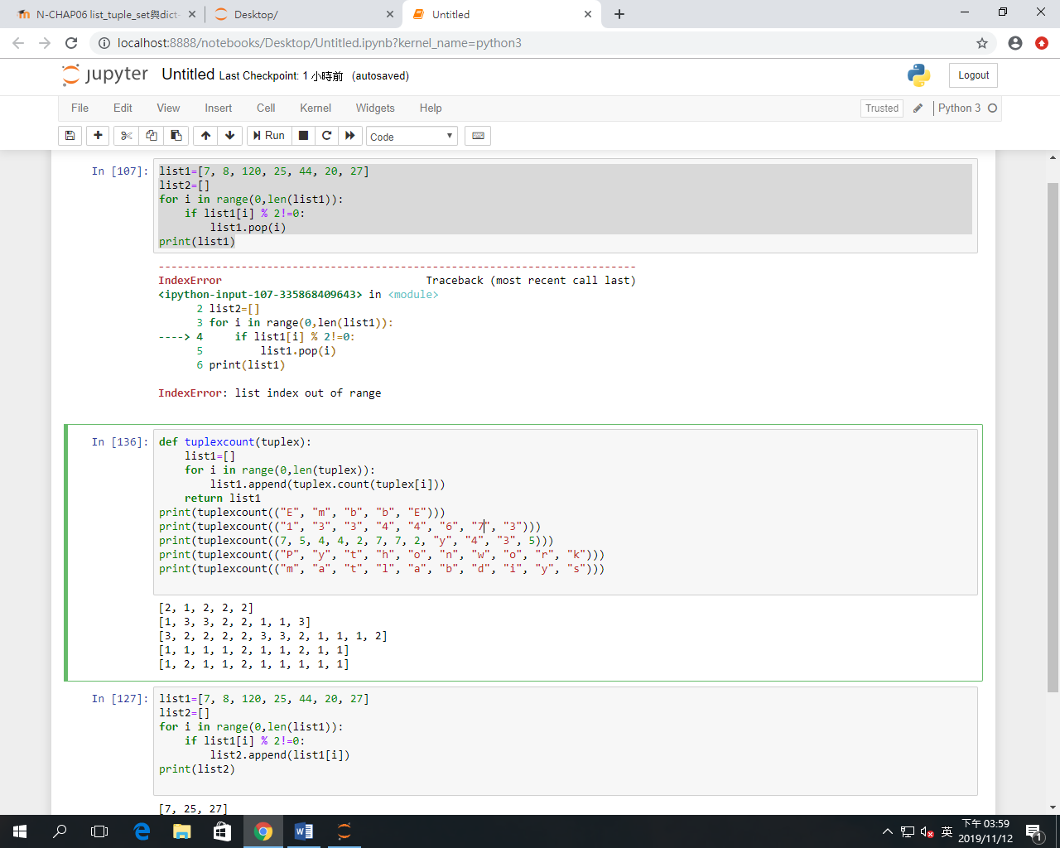

EX 8: 試撰寫一個Python函式lsttuple(lst)，其傳遞進來的list裡是由tuple所構成的內容。函式的功能是將所傳遞進來的list裡每一筆tuple的末端值更改為100，並且回傳。

例如:

|  |  |
| --- | --- |
| **輸入** | **執行結果** |
| **print(lsttuple([(10, 20, 40), (40, 50, 60), (70, 80, 90)]))** | [(10, 20, 100), (40, 50, 100), (70, 80, 100)] |
| **print(lsttuple([(20, 20), (400, 150), (70, 80), (2, 3)]))** | [(20, 100), (400, 100), (70, 100), (2, 100)] |

我的作答：

**請在下面欄位貼上程式碼：**

|  |
| --- |
|  |

**請依下面要求輸入參數，並將執行結果擷圖:**

|  |  |
| --- | --- |
| **print(lsttuple([(10, 20, 40), (40, 50, 60), (70, 80, 90)]))** | **[(10, 20, 100), (40, 50, 100), (70, 80, 100)]** |
| **print(lsttuple([(20, 20), (400, 150), (70, 80), (2, 3)]))** | **[(20, 100), (400, 100), (70, 100), (2, 100)]** |
| **print(lsttuple([(100, 20), (140, 350, 60)]))** | **[(100, 100), (140, 350, 100)]** |
| **print(lsttuple([(210, 220, 33, 333), (400, 150, 77), (1170, 180)]))** | **[(210, 220, 33, 100), (400, 150, 100), (1170, 100)]** |
| **print(lsttuple([(200,), (400, 150, 77, 1170, 180)]))** | **[(100,), (400, 150, 77, 1170, 100)]** |

**執行結果擷圖：**

EX 9: 同EX3的題目，試以串列解析式語法撰寫一個Python函式lsttuple(lst)，其傳遞進來的list裡是由tuple所構成的內容。函式的功能是將所傳遞進來的list裡每一筆tuple的末端值更改為100，並且回傳。

例如:

|  |  |
| --- | --- |
| **輸入** | **執行結果** |
| **print(lsttuple([(10, 20, 40), (40, 50, 60), (70, 80, 90)]))** | [(10, 20, 100), (40, 50, 100), (70, 80, 100)] |
| **print(lsttuple([(20, 20), (400, 150), (70, 80), (2, 3)]))** | [(20, 100), (400, 100), (70, 100), (2, 100)] |

我的作答：

**請在下面欄位貼上程式碼：**

|  |
| --- |
|  |

**請依下面要求輸入參數，並將執行結果擷圖:**

|  |  |
| --- | --- |
| **print(lsttuple([(10, 20, 40), (40, 50, 60), (70, 80, 90)]))** | **[(10, 20, 100), (40, 50, 100), (70, 80, 100)]** |
| **print(lsttuple([(20, 20), (400, 150), (70, 80), (2, 3)]))** | **[(20, 100), (400, 100), (70, 100), (2, 100)]** |
| **print(lsttuple([(100, 20), (140, 350, 60)]))** | **[(100, 100), (140, 350, 100)]** |
| **print(lsttuple([(210, 220, 33, 333), (400, 150, 77), (1170, 180)]))** | **[(210, 220, 33, 100), (400, 150, 100), (1170, 100)]** |
| **print(lsttuple([(200,), (400, 150, 77, 1170, 180)]))** | **[(100,), (400, 150, 77, 1170, 100)]** |

**執行結果擷圖：**

EX 10:試撰寫一個Python函式lsttupleL(lst)，函式的功能是將所傳遞進來的list裡的空tuple (empty tuple)刪除後回傳。

例如:

|  |  |
| --- | --- |
| **輸入** | **執行結果** |
| **print(lsttupleL([(), (), ('',), ('a', 'b'), ('a', 'b', 'c'), ('d')])) # ('',) is a tuple** | **[('',), ('a', 'b'), ('a', 'b', 'c'), 'd']** |
| **print(lsttupleL([(100, 20), (''), (140, 350, 60)])) # ('') not a tuple, it's a string** | **[(100, 20), '', (140, 350, 60)]** |

我的作答：

**請在下面欄位貼上程式碼：**

|  |
| --- |
|  |

**請依下面要求輸入參數，並將執行結果擷圖:**

|  |  |
| --- | --- |
| **print(lsttupleL([(), (), ('',), ('a', 'b'), ('a', 'b', 'c'), ('d')])) # ('',) is a tuple** | **[('',), ('a', 'b'), ('a', 'b', 'c'), 'd']** |
| **print(lsttupleL([(20, 20), (), (), (2, 3)]))** | **[(20, 20), (2, 3)]** |
| **print(lsttupleL([(100, 20), (''), (140, 350, 60)])) # ('') not a tuple, it's a string** | **[(100, 20), '', (140, 350, 60)]** |
| **print(lsttupleL([(210, 220, 33, 333), (), (1170, 180)]))** | **[(210, 220, 33, 333), (1170, 180)]** |
| **print(lsttupleL([(200,), ('',)]))** | **[(200,), ('',)]** |

**執行結果擷圖：**